Car Rider Directions for Students

Please Share with Car riders in 4th Core and 2nd encore

* **Share the map below**
* **A box: is where line A students stand and enter their vehicles**
* **B triangle: is where line B students stand and enter their vehicles**
* **C** Parallelogram: **is where line B students stand and enter their vehicles**

***Line B & C riders cross here***

**CROSSWALK**

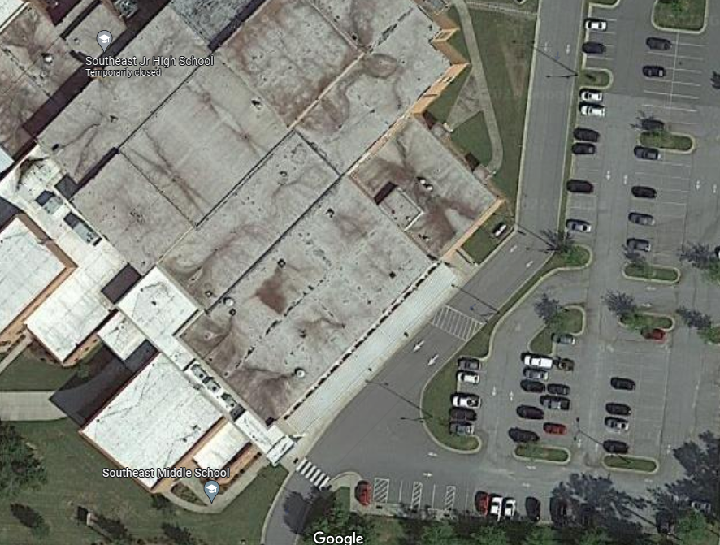

Crosswalk

**C**

B

A